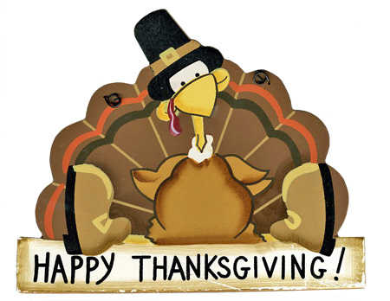

WELCOME TO THE BLACK OLIVE RESTAURANT

THANKSGIVING BREAKFAST SPECIALS

ALL SPECIALS ARE SERVED WITH COFFEE OR HOT TEA

1. THREE EGGS ANY STYLE WITH CHOICE OF MEAT……..…$6.99

SERVED WITH HOME FRIES, TOAST AND JELLY

1. THANKSGIVING COMBO……………...………………………...$9.99

SHORT STACK OF PUMPKIN PANCAKES, TWO EGGS SCRAMBLED,

CANADIAN BACON, CUP OF CHIPPED BEEF AND HOME FRIES

1. COUNTRY OMELETTE……….………………...…..……………$8.29

WITH SAUSAUGE, HAM, BACON, GREEN PEPPERS, ONIONS, TOMATO, MUSHROOMS AND SWISS CHEESE SERVED WITH HOME FRIES, TOAST AND JELLY

1. MARYLAND STYLE EGGS BENEDICT………………...………$8.49

TWO POACHED EGGS, SAUTEED SPINACH AND LUMP CRABMEAT ON

AN ENGLISH MUFFIN TOPPED WITH HOLLANDAISE SAUCE SERVED

WITH HOME FRIES

1. CHIPPED BEEF……………………………………………..…..…$6.99

SERVED OVER TOAST WITH A SIDE OF HOME FRIES

1. VEGETABLE TRIO OMELETTE……………….………………..$7.99

BROCCOLI, TOMATO AND MUSHROOMS WITH PROVOLONE CHEESE SERVED WITH HOME FRIES, TOAST AND JELLY

1. WAFFLE DELIGHT……………………………………………….$8.29

TOPPED WITH FRESH STRAWBERRIES AND BANANAS WITH POWERED SUGAR AND WHIPPED CREAM

1. NEW YORK STEAK AND EGGS…………..………………….$12.99

TWO EGGS ANY STYLE SERVED WITH HOME FRIES, TOAST AND JELLY

ALL SPECIALS INCLUDE COFFEE

ENJOY YOUR BREAKFAST AND HAPPY THANKSGIVING